By default CRM limits the number of records exported from the system into excel to 10,000 records. This feature allows increasing that limit where more than 10,000 records are required to be exported

To update the limit for an excel export click ‘Update Excel Export Limit’ from the main menu

In the form modify the value and click save

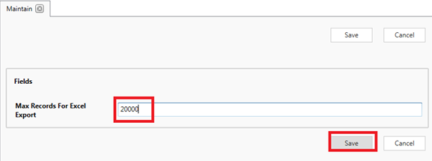

The limit will now be set to the new value you entered